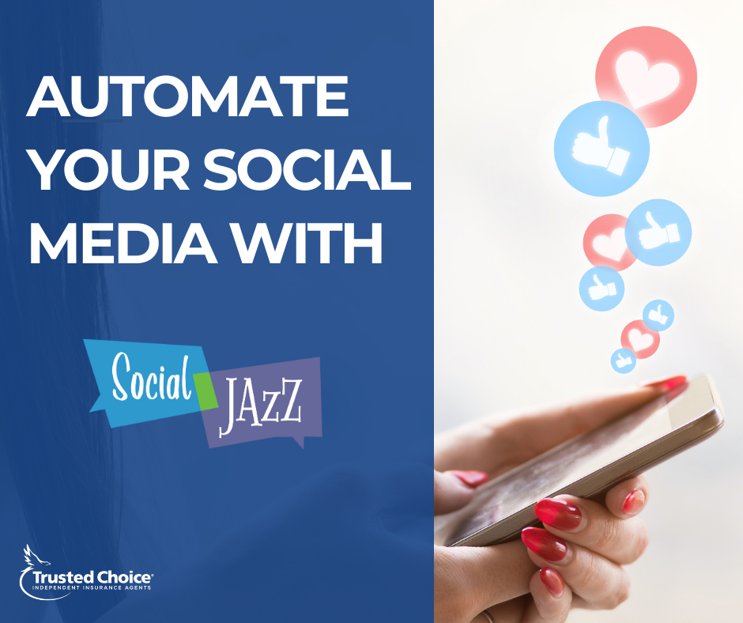
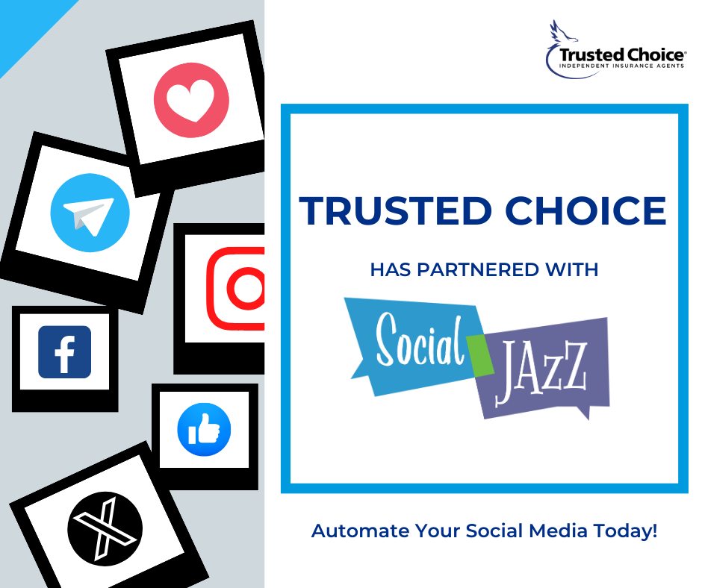
Copy: Streamline your agency's online presence like never before! Trusted Choice has partnered with Social Jazz to provide you with automated posting and personalized content creation at an unmatched value of just $15 a month. Elevate your social media strategy with ease today! Get started!

Copy: You asked, we answered! Transform your agency's social media game with Trusted Choice’s exciting partnership with Social Jazz! For just $15/month, you can receive automated posting and tailored content creation to elevate your online presence effortlessly and affordably. Get started!
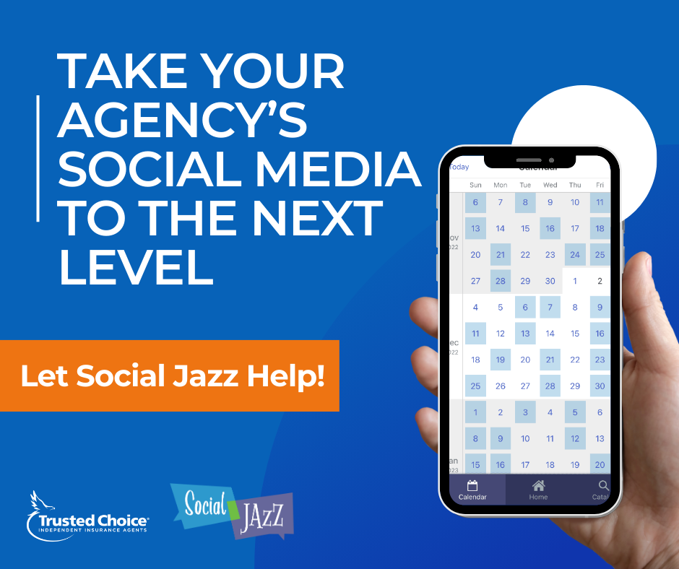
Copy: Maximize your agency's impact on social media with Social Jazz! Unleash the potential of automated posting and personalized content creation. Trusted Choice partnered with Social Jazz to provide Big “I” members this service at a discounted rate of $15/mo! Try today!
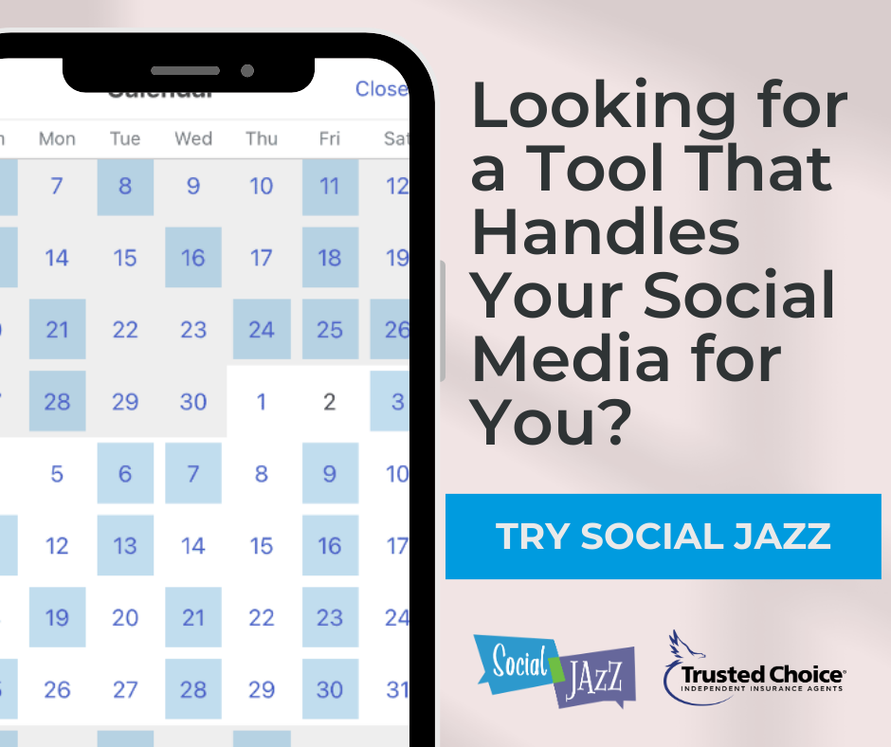

Copy: Say goodbye to social media stress and hello to efficiency! Trusted Choice has partnered with Social Jazz to bring Big “I” members seamless social media automation and engaging content with no extra work for you. At a discounted price of $15/mo, this tool can handle your social media for you. Try Social Jazz today!

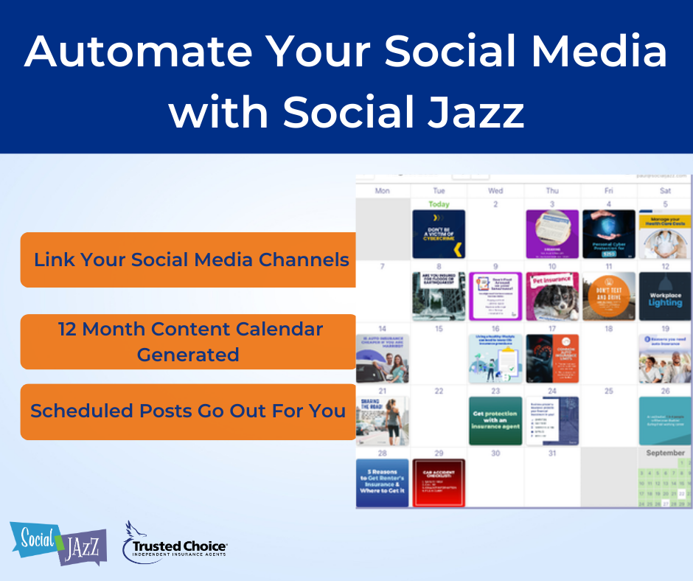

Copy: Want your agency to be present on social media, but don’t have the resources to do so? Trusted Choice has partnered with Social Jazz to help! Whether you prefer to simply “set it and forget it” or be a bit more hands on, Social Jazz provides automated posting and personalized content creation. Check it out today!

