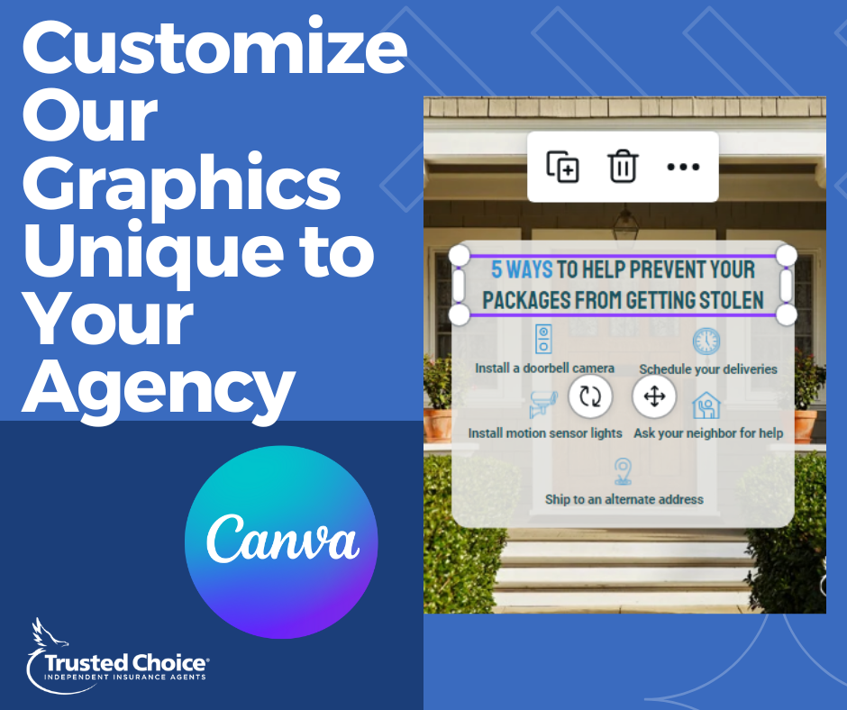
Copy: “It's time to get creative! Members can now unleash their design skills with Canva. Edit, customize, and personalize Trusted Choice social media content graphics to make them a perfect fit for your agency. Check out the Canva templates for the month today! https://trustedchoice.independentagent.com/content-calendar/”

